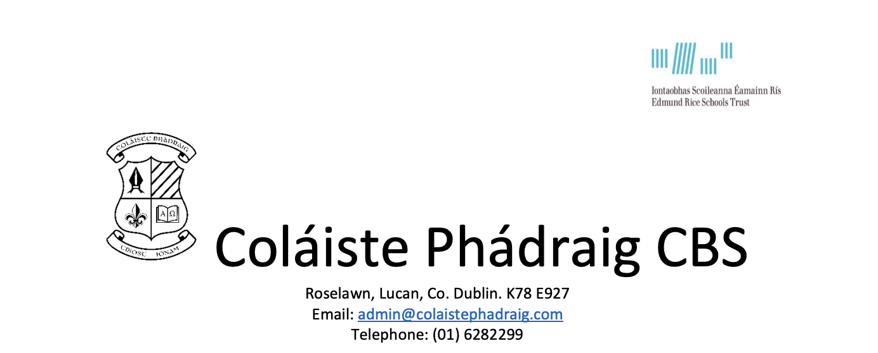

26/04/2024
A Chara,
Thank you for contacting us in relation to the re-advertised position of Principal in Coláiste Phádraig, Lucan.
The post of Principal will commence on 1/9/2024 and will be filled in accordance with the following:
- The Edmund Rice Schools Trust Charter
- Articles 20 and 21 of the Articles of Management for Catholic Secondary Schools
- Department of Education & Skills Circular 04/98
- Department of Education & Skills Circular 62/2021
- Role Profile for the position of the Principal

Further information about the school is available on the school’s website, Coláiste Phádraig | School in Lucan (colaistephadraiglucan.ie)

The Application Form is available here and the links the five associated documents are below. These should be read to assist you in completing the form and gain an understanding of the application process.
- The Edmund Rice Schools Trust Charter, available here
- Circular 04/98, available here
- Circular 62/2021, available here
- Articles 20 and 21 of the Articles of Management, available here
- Role Profile of Principal, available here

Completed Application Forms should be emailed to erstcompetitions@outlook.ie by 12 noon on 13th May 2024.
Yours,
Mary Edel Ryan
Chairperson BOM

