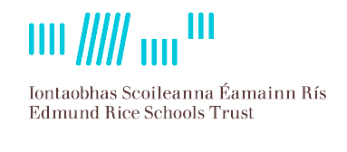
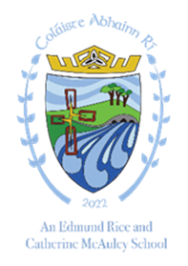
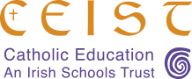

Coláiste Abhainn Rí Callan Co Kilkenny
Mission Statement

We are a Christian school community of inclusion and care rooted in the
Catholic ethos of teaching and learning. We are committed to
maximising the potential of each student in an atmosphere of mutual
respect. We place our students at the heart of everything we do.

