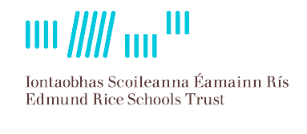
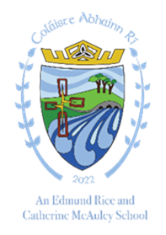
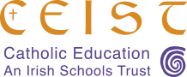

Philosophy of Education and Characteristic Spirit
Coláiste Abhainn Rí Callan
(Amalgamated School of Coláiste Éamann Rís Callan and St. Brigid’s College Callan)
Mission Statement
We are a Christian school community of inclusion and care rooted in the
Catholic ethos of teaching and learning. We are committed to
maximising the potential of each student in an atmosphere of mutual
respect. We place our students at the heart of everything we do.
Coláiste Abhainn Rí is a Catholic co-educational voluntary secondary school with a Catholic Ethos under the joint trusteeship of ERST and CEIST.
“Catholic Ethos” in the context of a Catholic voluntary secondary school means the ethos and characteristic spirit of the Roman Catholic Church, which aims at promoting:

- the full and harmonious development of all aspects of the person of the pupil, including the intellectual, physical, cultural, moral and spiritual aspects; and
- a living relationship with God and with other people; and
- a philosophy of life inspired by belief in God and in the life, death and resurrection of
Jesus; and
- the formation of the pupils in the Catholic faith,

and which school provides religious education in accordance with the doctrines, practices and
traditions of the Roman Catholic Church, and/or such ethos and/or characteristic spirit as may
be determined or interpreted from time to time by the Irish Episcopal Conference.
In accordance with S.15 (2) (b) of the Education Act, 1998 the Board of Management of
Coláiste Abhainn Rí shall uphold, and be accountable to the patrons for so upholding, the
characteristic spirit of the school as determined by the cultural, educational, moral, religious,
social, linguistic and spiritual values and traditions which inform and are characteristic of the
objectives and conduct of the school.
Coláiste Abhainn Rí has come about as an amalgamation of Coláiste Éamann Rís founded by the Christian Brothers and St. Brigid’s College Callan founded by the Mercy Sisters. The values and strengths of both these schools and their strong shared tradition of faith and community will be at the heart of the new school Coláiste Abhainn Rí, as will the richness of the shared religious and cultural heritage of both our present patrons ERST and CEIST.
Coláiste Abhainn Rí values teaching as one of the most important of all human activities. Our school
seeks to build a quality learning community that welcomes, and bears witness to the Gospel
values of Jesus Christ, expressed through the lens of the ERST and CEIST Charters. These are encapsulated in core values which are intended to support and nourish the lives of the people who are at the heart of our school.
• Promoting Spiritual and Human Development
• Achieving Quality in Teaching and Learning
• Showing Respect for Every Person
• Creating Community
• Being Just and Responsible
Coláiste Abhainn Rí is inspired by the words of Jesus Christ to his disciples, "I have come that they may have life and have it to the full" (Jn 10:10). Because of this, Coláiste Abhainn Rí provides a rich, holistic education in the Catholic tradition where engagement with and development of the whole person; the intellectual, moral, religious, physical, spiritual and psychological are at the core of our practice.
Education has as its goal the formation of a human person who is free, rational and mature
in relationships. Coláiste Abhainn Rí offers educational opportunities which promote excellence so
that students can respond responsibly and creatively to their own lives, the lives of others
and to the earth, which is our common home.
In Coláiste Abhainn Rí the dignity and uniqueness of every human being as a child of God is
acknowledged and affirmed. The Catholic school is an inclusive community, ideally built on
love and formed by the interaction and collaboration of its various components: students,
parents, teachers, non-teaching staff and members of the Board of Management.
Catholic schools are also outward looking. They are connected to their local parish and
Diocese and other local organisations which enrich the life of the school. Our school draws
on the rich resources of the local community and, in turn, contributes to the life of the local
community.
As a Catholic school, Religious Education is central to our curriculum. Alongside Religious Education, the school supports the formation in faith of our students through many school based experiences of prayer and ritual. All students’ spiritual growth is further enhanced through such areas as sport, language, nature, an, poetry and music.
We in Coláiste Abhainn Rí, in cooperation with parents/guardians, aim to foster and develop the unique potential of each student through the provision of a broad based educational experience in the Catholic tradition.
ln welcoming all, our focus is on educational excellence delivered in a safe and caring environment. Mutual respect, responsibility and belonging permeate all that we do enabling the holistic development of our students.

